Bryan Cabrera

Module 3.2 Assignment

6/7/2024

**Screenshots:**

*HTML Check:* 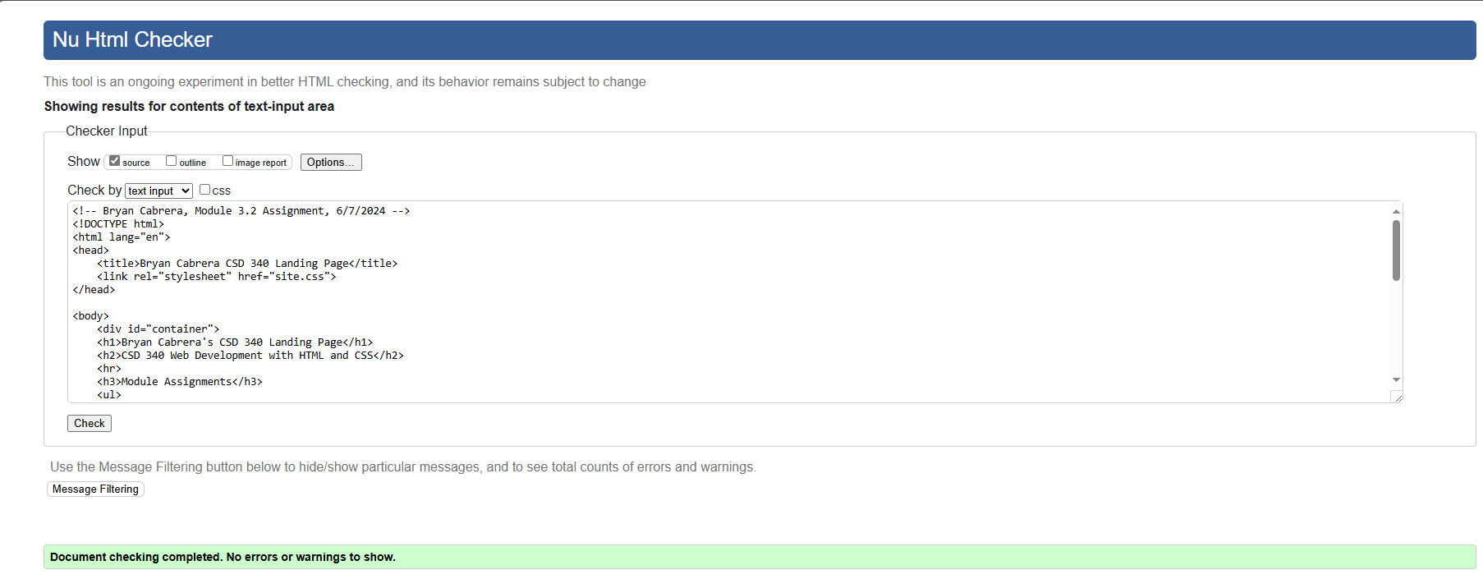

*CSS Check:*

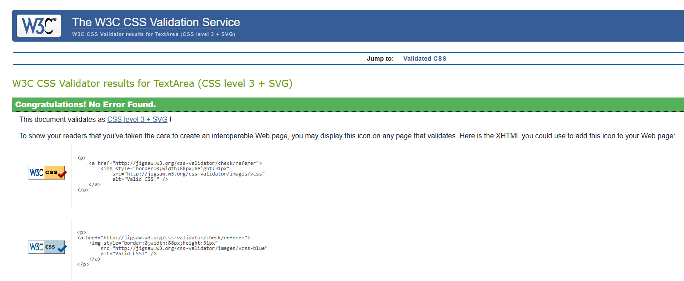

*Web Page:*

